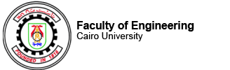

**Languages and Compilers Project**

**Team: 13**

**Workload**

|  |  |  |  |
| --- | --- | --- | --- |
| Abdelrahman Hashim | Ehab Rabie | Israa Ashraf | Sara Ahmed |
|  |  |  |  |